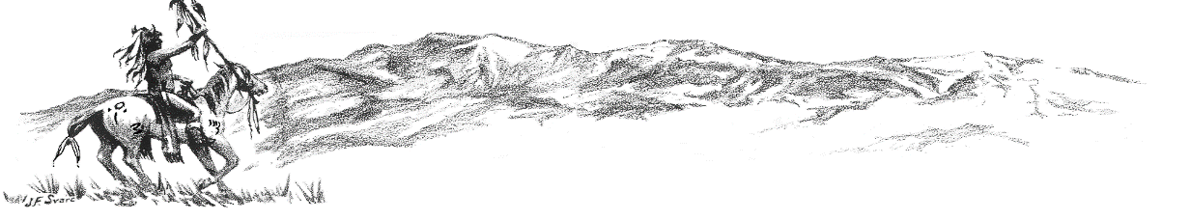
Colorado City Happenings January 2023

Did you notice a difference in your water bill?
Due to the water rate increase that took effect January 1, 2023, your billing may show a minimal increase in your water charge. If you have any questions regarding your billing, please contact CCMD 719-676-3396.

Lake Beckwith Dam Project
The project to repair and prepare Lake Beckwith Dam for future expansion of raw water storage is actively moving forward. The Board of Directors and City Management are committed to complying with State of Colorado dam safety mandates and providing dependable adequate water for the future of Colorado City. CCMD has contracted with Atencio Engineering to assist in procuring funding and RJH Engineering to do engineering and design. Funding request packets are being prepared and will be presented to potential funding agencies mid-February.
Letters of support from citizens, businesses, and any affected organizations would be helpful. The mid-February deadline is quickly approaching so if you would like to include a letter, please contact the CCMD office soon at 719-676-3396.

Town Hall Chat
A Reminder!
CCMD will be hosting an informal town hall chat February 21 at 6:00 p.m. The get together will be a chance to visit and learn from any and all citizens willing to attend. No decisions will be made, or policy enacted…. just discussion.

May Election for CCMD Board Members
There will be an election Tuesday, May 9, 2023, to fill three positions on the Colorado City Metropolitan District Board of Directors. To be eligible to be a Director you must own property or be a resident of Colorado City. Self-nomination forms are available from the Designated Election Official (DEO) James Naron, or on the CCMD website colocitymd.colorado.gov, or at the CCMD office. Self-nomination forms must be filed with the DEO or the CCMD office by February 24, 2023.

Water Line Replacement and Water Tank Repair
Water line replacement on Talley Drive and Waco Mish is nearing completion. Pate Construction is finishing connections of the line on Waco Mish and has tied in most of the meters to a new line. Thank you for your patience when water was off temporarily for tie ins and flushing.
Yocum Construction is waiting for a pressure reducing valve and a vault to finish the new line on Talley Drive.
As the winter weather breaks you will notice Swedish Industrial Coatings working on water tanks 1, 2, and 3.

Colorado City Architectural Control Committee
Thank you to all that have helped with clean up and efforts to keeping Colorado City a proud community and desirable place to live. CCACC has noticed some improvements in covenant compliance, but we all still have much more work to do. If your property needs clean up or covenant attention, please take action to correct any issues and encourage your neighbors to do the same. Covenants are available on the CCMD website: coloradocitymd.colorado.gov.
If you notice illegal dumping in Colorado City (or any place in Pueblo County), please call Pueblo County Sheriff 719-583-6250.
Remember: All construction projects (including roofing) require a permit from Pueblo County Regional Building Department and CCMD. Please call 719-676-3396 if you have any questions.

Recreation Center
Josh Briggs, Colorado City Parks and Rec Director, is continuing to enhance utilization of the Rec Center for activities for both youth and adults. In the works is a schedule for adult/senior games and chats on Tuesday and Thursdays 8am-11am. Game tables (pool, foosball, card tables, etc.) are installed and ready to use. Volunteers are welcome to help staff the center during open times. Call Josh at 719-676-3059 or visit the website cocityparksandrec.colorado.gov for more info.

