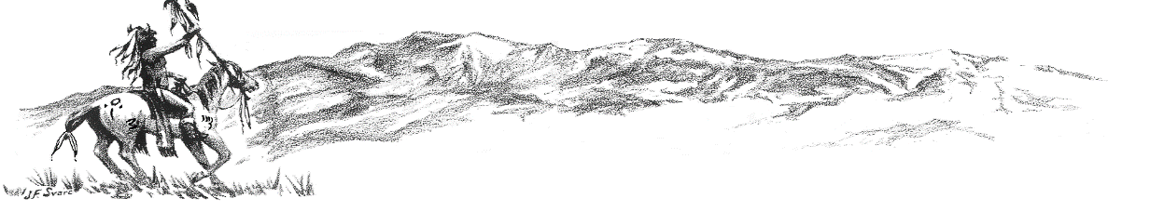
Colorado City Happenings February 2023

Did you notice a difference in your water bill?
Due to the water rate increase that took effect January 1, 2023, your billing may show a minimal increase in your water charge. If you have any questions regarding your billing, please contact CCMD 719-676-3396.
Lake Beckwith Dam Project
The project to repair and prepare Lake Beckwith Dam for future expansion of raw water storage is actively moving forward. The Board of Directors and City Management are committed to complying with State of Colorado dam safety mandates and providing dependable adequate water for the future of Colorado City. CCMD has contracted with Atencio Engineering to assist in procuring funding and RJH Engineering to do engineering and design. Funding request packets presented to Arkansas Basin Round Table for potential funding agencies and are being reviewed.
Town Hall Chat
CCMD will be hosting an informal town hall chat May 16, 2023, at 6:00 p.m. The get together will be a chance to visit and learn from any and all citizens willing to attend. No decisions will be made, or policy enacted…. just discussion. This will be a good chance to meeting new board members.
May Election for CCMD Board Members
There will be an election Tuesday, May 2, 2023, to fill three, four-year term positions on the Colorado City Metropolitan District Board of Directors. To be eligible to be a Director you must own property or be a resident of Colorado City and be a registered voter. Two of the present board members are term limited and cannot run in the election.
Water Line Replacement and Water Tank Repair
Water line replacement on Talley Drive and Waco Mish is nearing completion. Pate Construction is complete with waterline installed and will be finishing in end of April or beginning of May after the road surface is repaved. Thank you for your patience when water was off temporarily for tie ins and flushing.
Yocum Construction has received a pressure reducing valve and a vault to finish the new line on Talley Drive, Due to weather the last couple of weeks it has stopped the process to complete the project.
As the winter weather breaks you will notice Swedish Industrial Coatings working on water tanks 1, 2, and 3.

Colorado City Architectural Control Committee
Thank you to all that have helped with clean up and efforts to keep Colorado City a proud community and desirable place to live. CCACC has noticed some improvements in covenant compliance, but we all still have much more work to do. If your property needs clean up or covenant attention, please take action to correct any issues and encourage your neighbors to do the same. Covenants are available on the CCMD website: coloradocitymd.colorado.gov.
If you notice illegal dumping in Colorado City (or any place in Pueblo County), please call Pueblo County Sheriff 719-583-6250.
Remember: All construction projects (including roofing) require a permit from Pueblo County Regional Building Department and CCMD. Please call 719-676-3396 if you have any questions.
Recreation Center
Josh Briggs, Colorado City Parks and Rec Director, is continuing to enhance and utilization of the Rec Center for activities for both youth and adults. He has scheduled a time for adult/senior games and chats on Tuesday and Thursdays 8am-11am. Game tables (pool, foosball, card tables, etc.) are installed and ready to use. Volunteers are welcome to help staff the center during open times. Call Josh at 719-676-3059 or visit the website cocityparksandrec.colorado.gov for more info.
Sewer charges
Remember this is the time of year that your sewer rate is calculated December, January, and February as stated in previous bills. This is a good time to check your toilet for leaks. The best way is to put food coloring in tank without flushing and walk away for ten minutes. When you come back check the bowl to see if water changed color if it did you have a leak. It could be the stopper, float, and other issues that might need to be checked and replaced.
Water Meters, Pits and Covers
This is Colorado City Metropolitan District property, and it is illegal to tamper with and can result in legal charges as well as charged for any damages caused to the equipment. If you need assistance with water to be shut off or turned on, please call 719-676-3396.

